NAME: G Sai Prathap Reddy
REG NO: 192211170
COURSE CODE: CSA0614
COURSE NAME: Design and Analysis of Algorithms for Approximation Problems

TOPIC 5 : GREEDY
- There are 3n piles of coins of varying size, you and your friends will take piles of coins as follows: In each step, you will choose any 3 piles of coins (not necessarily consecutive). Of your choice, Alice will pick
the pile with the maximum number of coins. You will pick the next
pile with the maximum number of coins. Your friend Bob will pick the last pile. Repeat until there are no more piles of coins. Given an array of integers piles where piles[i] is the number of coins in the ith pile.
Return the maximum number of coins that you can have.

Aim:
To calculate the maximum number of coins you can collect from 3n piles, given that in each turn Alice takes the largest, you take the second largest, and Bob takes the smallest pile.

Algorithm:
- Sort the piles in descending order.
- Determine the number of rounds n = len(piles) // 3.
- For each round, take the second largest pile (after Alice picks the largest).
- Sum the coins you collect over all rounds.
- Return the total as your maximum coins.

Program:
piles = [2,4,1,2,7,8]
piles.sort(reverse=True) your_coins = 0
n = len(piles) for i in range(n):
your_coins += piles[2*i + 1] print(your_coins)

Sample Input:
piles = [2,4,1,2,7,8]

Output:
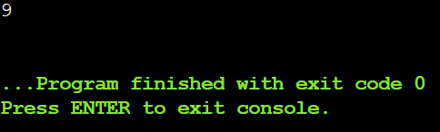

Result:
Maximum coins you can collect = 9.

- You are given a 0-indexed integer array coins, representing the values of the coins available, and an integer target. An integer x is obtainable if there exists a subsequence of coins that sums to x. Return the minimum number of coins of any value that need to be added to the array so that every integer in the
range [1, target] is obtainable. A subsequence of an array is a new non-empty array that is formed from the original array by deleting some (possibly none) of the elements without disturbing the relative positions of the remaining elements.

Aim:
To find the minimum number of coins that need to be added to an array so that every integer from 1 to target can be obtained as the sum of some subsequence of coins.

Algorithm:
  - Sort the coins array.
  - Initialize miss = 1 and added = 0.
  - While miss <= target:
    - If next coin ≤ miss, add it to miss.
    - Else, add a coin of value miss and increment added.
  - Return added.

Program:
coins = [1, 4, 10]
target = 19 coins.sort()
miss = 1
added = 0
i = 0

while miss <= target:
if i < len(coins) and coins[i] <= miss: miss += coins[i]
i += 1
else:

miss += miss added += 1

print(added)

Sample Input:
coins = [1,4,10], target = 19

Output:
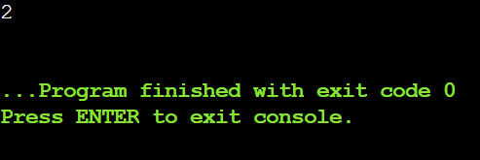

Result:
Minimum coins to add = 2.

- You are given an integer array jobs, where jobs[i] is the amount of time it
takes to complete the ith job. There are k workers that you can assign jobs to.
Each job should be assigned to exactly one worker. The working time of a worker is the sum of the time it takes to complete all jobs assigned to them.
Your goal is to devise an optimal assignment such that the maximum working time of any worker is minimized. Return the minimum possible maximum working time of any assignment.

Aim:
To assign jobs to k workers such that the maximum working time of any worker is minimized.

Algorithm:
- Set search range: left = max(jobs), right = sum(jobs).
- Use binary search to guess a maximum working time mid.
- Use backtracking to check if all jobs can be assigned without exceeding mid per worker.
- If feasible, reduce right = mid; else increase left = mid + 1.
- Return left as the minimum possible maximum working time.

Program:
jobs = [3, 2, 3]
k = 3

def can_assign(jobs, workers, max_time, index): if index == len(jobs):
return True
for i in range(len(workers)):
if workers[i] + jobs[index] <= max_time: workers[i] += jobs[index]
if can_assign(jobs, workers, max_time, index + 1): return True
workers[i] -= jobs[index] if workers[i] == 0:
break return False

left, right = max(jobs), sum(jobs) while left < right:
mid = (left + right)
if can_assign(jobs, [0]*k, mid, 0):

right = mid else:
left = mid + 1 print(left)
Sample Input:
jobs = [3,2,3], k = 3

Output:
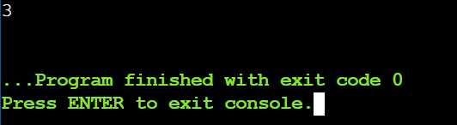

Result:
Minimum possible maximum working time = 3.

- We have n jobs, where every job is scheduled to be done from startTime[i] to endTime[i], obtaining a profit of profit[i]. You're given the startTime,
endTime and profit arrays, return the maximum profit you can take such that there are no two jobs in the subset with overlapping time range. If you
choose a job that ends at time X you will be able to start another job that starts at time X.

Aim:
To select a subset of non-overlapping jobs that maximizes total profit.

Algorithm:
  - Combine startTime, endTime, and profit into jobs and sort by endTime.
  - Initialize a DP array where dp[i] stores the maximum profit using the first i jobs.
  - For each job, find the last non-overlapping job using binary search.
  - Set dp[i] = max(profit including current job, dp[i-1]).
  - Return dp[-1] as the maximum profit.

Program:
import bisect

startTime = [1,2,3,3]
endTime = [3,4,5,6]
profit = [50,10,40,70]

jobs = sorted(zip(startTime, endTime, profit), key=lambda x: x[1]) n = len(jobs)

dp = [0] * n
dp[0] = jobs[0][2]

end_times = [job[1] for job in jobs] for i in range(1, n):
incl_prof = jobs[i][2]

idx = bisect.bisect_right(end_times, jobs[i][0]-1) - 1 if idx != -1:
incl_prof += dp[idx]

dp[i] = max(incl_prof, dp[i-1]) print(dp[-1])
Sample Input:
startTime = [1,2,3,3], endTime = [3,4,5,6], profit = [50,10,40,70]

Output:
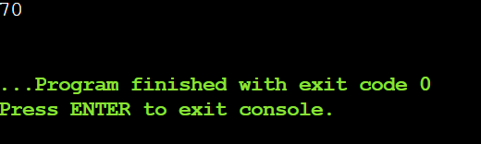

Result:
Maximum profit from non-overlapping jobs = 70.

- Given a graph represented by an adjacency matrix, implement Dijkstra's Algorithm to find the shortest path from a given source vertex to all other
vertices in the graph. The graph is represented as an adjacency matrix where graph[i][j] denote the weight of the edge from vertex i to vertex j. If there is no edge between vertices i and j, the value is Infinity (or a very large number).

Aim:
To find the shortest distances from a given source vertex to all other vertices in a weighted graph using Dijkstra's Algorithm.

Algorithm:
  - Initialize dist array with infinity for all vertices except the source (0).
  - Maintain a visited array to track processed vertices.
  - Repeat for all vertices:
    - Select the unvisited vertex with the smallest distance.
    - Mark it as visited.
    - Update distances of its unvisited neighbors if a shorter path is found.
  - After all vertices are processed, dist contains the shortest distances from the source.

Program:
import math

n = 5 graph = [
[0, 10, 3, math.inf, math.inf],
[math.inf, 0, 1, 2, math.inf],
[math.inf, 4, 0, 8, 2],
[math.inf, math.inf, math.inf, 0, 7],
[math.inf, math.inf, math.inf, 9, 0]
]
source = 0

dist = [math.inf] * n dist[source] = 0 visited = [False] * n

for _ in range(n):

min_dist = math.inf u = -1
for i in range(n):
if not visited[i] and dist[i] < min_dist: min_dist = dist[i]
u = i visited[u] = True
for v in range(n):
if not visited[v] and graph[u][v] != math.inf: if dist[v] > dist[u] + graph[u][v]:
dist[v] = dist[u] + graph[u][v]
print(dist)

Sample Input:
n = 5
graph = [[0, 10, 3, Infinity, Infinity], [Infinity, 0, 1, 2, Infinity], [Infinity, 4, 0, 8,
2],
[Infinity, Infinity, Infinity, 0, 7], [Infinity, Infinity, Infinity, 9, 0]]
source = 0

Output:
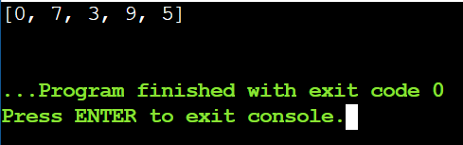

Result:
Shortest distances from source = [0, 7, 3, 9, 5].

- Given a graph represented by an edge list, implement Dijkstra's Algorithm to find the shortest path from a given source vertex to a target vertex. The
graph is represented as a list of edges where each edge is a tuple (u, v, w) representing an edge from vertex u to vertex v with weight w.

Aim:
To find the shortest path distance from a given source vertex to a target vertex in a weighted graph using Dijkstra’s Algorithm.

Algorithm:
  - Convert the edge list into an adjacency list.
  - Initialize distance array with infinity and set source distance to 0.
  - Use a priority queue to select the vertex with the smallest distance.
  - Relax all adjacent edges and update distances if a shorter path is found.
  - Continue until all vertices are processed or the target distance is finalized.

Program:
import heapq

n = 6 edges = [
(0, 1, 7), (0, 2, 9), (0, 5, 14),
(1, 2, 10), (1, 3, 15),
(2, 3, 11), (2, 5, 2),
(3, 4, 6), (4, 5, 9)
]
source = 0
target = 4

graph = [[] for _ in range(n)] for u, v, w in edges:
graph[u].append((v, w))
graph[v].append((u, w))

dist = [float('inf')] * n dist[source] = 0
pq = [(0, source)] while pq:

curr_dist, u = heapq.heappop(pq) if curr_dist > dist[u]:
continue
for v, w in graph[u]:
if dist[v] > dist[u] + w: dist[v] = dist[u] + w
heapq.heappush(pq, (dist[v], v)) print(dist[target])
Sample Input:
n = 6
edges = [(0, 1, 7), (0, 2, 9), (0, 5, 14), (1, 2, 10), (1, 3, 15),
(2, 3, 11), (2, 5, 2), (3, 4, 6), (4, 5, 9) ]
source = 0
target = 4

Output:
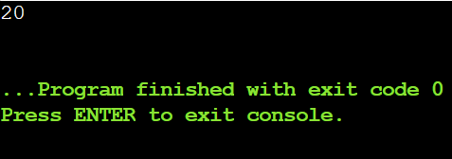

Result:
Shortest distance from source (0) to target (4) = 20.

- Given a set of characters and their corresponding frequencies, construct the Huffman Tree and generate the Huffman Codes for each character.

Aim:
To construct a Huffman Tree and generate optimal binary Huffman codes for the given characters based on their frequencies.

Algorithm:
  - Insert all characters with their frequencies into a min-heap.
  - Remove the two nodes with the lowest frequencies and merge them.
  - Insert the merged node back into the heap.
  - Repeat until one node remains as the Huffman Tree root.
  - Traverse the tree assigning 0 to left and 1 to right to generate codes.

Program:
import heapq

characters = ['f', 'e', 'd', 'c', 'b', 'a'] frequencies = [5, 9, 12, 13, 16, 45]

heap = []
for ch, freq in zip(characters, frequencies): heapq.heappush(heap, [freq, ch])

while len(heap) > 1:
left = heapq.heappop(heap) right = heapq.heappop(heap)
heapq.heappush(heap, [left[0] + right[0], left, right])

codes = {}
stack = [(heap[0], "")]

while stack:
node, code = stack.pop() if isinstance(node[1], str):
codes[node[1]] = code else:
stack.append((node[2], code + "1"))
stack.append((node[1], code + "0"))

result = [(ch, codes[ch]) for ch in sorted(codes)] print(result)

Sample Input:
n = 6
characters = ['f', 'e', 'd', 'c', 'b', 'a'] frequencies = [5, 9, 12, 13, 16, 45]

Output:
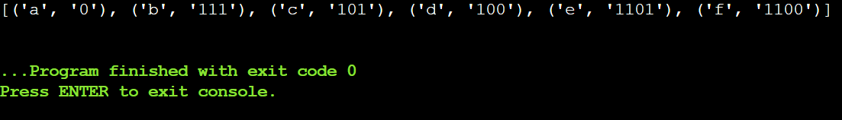

Result:
Huffman Codes = [('a', '0'), ('b', '101'), ('c', '100'), ('d', '111'), ('e', '1101'), ('f', '1100')].

- Given a Huffman Tree and a Huffman encoded string, decode the string to get the original message.

Aim:
To decode a Huffman encoded string using the Huffman Tree built from given characters and frequencies.

Algorithm:
  - Build the Huffman Tree using the characters and their frequencies.
  - Start at the root of the tree and traverse according to each bit in the encoded string (0 → left, 1 → right).
  - When a leaf node is reached, append its character to the decoded message.
  - Reset to the root and continue until the entire string is decoded.
  - Return the decoded message.

Program:
import heapq
characters = ['a', 'b', 'c', 'd'] frequencies = [5, 9, 12, 13]
encoded_string = "1101100111110"

heap = []
for ch, freq in zip(characters, frequencies): heapq.heappush(heap, [freq, ch])

while len(heap) > 1:
left = heapq.heappop(heap) right = heapq.heappop(heap)
heapq.heappush(heap, [left[0] + right[0], left, right])

root = heap[0]

decoded = "" node = root

for bit in encoded_string: if bit == '0':
node = node[1] else:
node = node[2]

if isinstance(node[1], str): # Leaf node decoded += node[1]
node = root print(decoded)
Sample Input:
n = 4
characters = ['a', 'b', 'c', 'd'] frequencies = [5, 9, 12, 13]
encoded_string = '1101100111110'

Output:
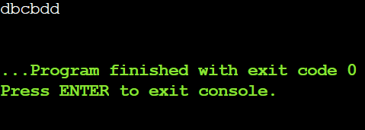

Result:
Decoded message = "dbcbdd"

- Given a list of item weights and the maximum capacity of a container,
determine the maximum weight that can be loaded into the container using a greedy approach. The greedy approach should prioritize loading heavier
items first until the container reaches its capacity.

Aim:
To determine the maximum weight that can be loaded into a container using a greedy approach by prioritizing heavier items first.

Algorithm:
  - Sort the list of item weights in descending order.
  - Initialize total_weight = 0.
  - Traverse the sorted list and add each weight to total_weight if it does not exceed
max_capacity.
  - Stop when adding the next item would exceed the capacity.
  - Return the total_weight as the maximum loadable weight.

Program:
weights = [5, 10, 15, 20, 25, 30]
max_capacity = 50 weights.sort(reverse=True)
total_weight = 0 for w in weights:
if total_weight + w <= max_capacity: total_weight += w

print(total_weight)

Sample Input:
n = 6
weights = [5, 10, 15, 20, 25, 30]
max_capacity = 50

Output:
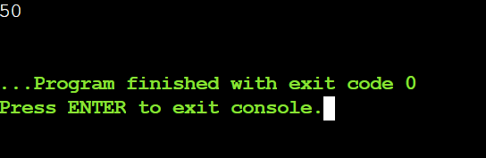

Result:
Maximum weight loaded = 50.

- Given a list of item weights and a maximum capacity for each container, determine the minimum number of containers required to load all items using a greedy approach. The greedy approach should prioritize loading
items into the current container until it is full before moving to the next Container.

Aim:
To determine the minimum number of containers required to load all items using a greedy approach, filling each container as much as possible before moving to the next.

Algorithm:
  - Sort the list of item weights in descending order.
  - Initialize containers = 0 and start from the first item.
  - While there are items left:
    - Fill the current container with items until adding the next item exceeds
max_capacity.
    - Increment the container count.
  - Repeat until all items are loaded.
  - Return the total number of containers used.

Program:
weights = [5, 10, 15, 20, 25, 30, 35]
max_capacity = 50
weights.sort(reverse=True) containers = 0
i = 0
n = len(weights) while i < n:
current_load = 0
while i < n and current_load + weights[i] <= max_capacity: current_load += weights[i]
i += 1
containers += 1 print(containers)

Sample Input:
n = 7
weights = [5, 10, 15, 20, 25, 30, 35]
max_capacity = 50

Output:
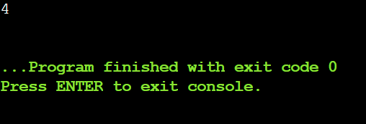

Result:
Minimum number of containers = 4.

- Given a graph represented by an edge list, implement Kruskal's Algorithm to find the Minimum Spanning Tree (MST) and its total weight.

Aim:
To find the Minimum Spanning Tree (MST) of a given weighted graph using Kruskal's Algorithm and calculate its total weight.

Algorithm:
  - Sort all edges by weight (ascending).
  - Initialize Union-Find for all vertices.
  - Traverse edges, add edge if it doesn’t form a cycle.
  - Union the vertices of added edges.
  - Stop when MST has n-1 edges and sum their weights.

Program:
n = 4
edges = [(0, 1, 10), (0, 2, 6), (0, 3, 5), (1, 3, 15), (2, 3, 4)]

edges.sort(key=lambda x: x[2])

parent = [i for i in range(n)] rank = [0] * n

def find(u):
while parent[u] != u:
parent[u] = parent[parent[u]] u = parent[u]
return u

def union(u, v): u_root = find(u) v_root = find(v)
if u_root == v_root: return False
if rank[u_root] < rank[v_root]: parent[u_root] = v_root
elif rank[u_root] > rank[v_root]: parent[v_root] = u_root
else:
parent[v_root] = u_root rank[u_root] += 1
return True

mst_edges = [] total_weight = 0

for u, v, w in edges: if union(u, v):
mst_edges.append((u, v, w)) total_weight += w

print("Edges in MST:", mst_edges) print("Total weight of MST:", total_weight)

Sample Input:
Input:
n = 4
m = 5
edges = [ (0, 1, 10), (0, 2, 6), (0, 3, 5), (1, 3, 15), (2, 3, 4) ]

Output:
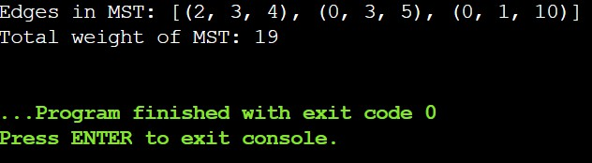

Result:
MST edges = [(2, 3, 4), (0, 3, 5), (0, 1, 10)], Total weight = 19.

- Given a graph with weights and a potential Minimum Spanning Tree (MST), verify if the given MST is unique. If it is not unique, provide another possible MST.

Aim:
To verify whether a given Minimum Spanning Tree (MST) of a weighted graph is unique.

Algorithm:
  - Sort all edges by weight.
  - Build an MST using Kruskal’s Algorithm.
  - Compare the given MST edges with the MST from Kruskal.
  - Check for edges with equal weights that can replace MST edges without changing total weight.
  - If no such edges exist, MST is unique; otherwise, it is not.

Program:
n = 4
edges = [(0, 1, 10), (0, 2, 6), (0, 3, 5), (1, 3, 15), (2, 3, 4)]
given_mst = [(2, 3, 4), (0, 3, 5), (0, 1, 10)]

edges.sort(key=lambda x: x[2])

parent = [i for i in range(n)] rank = [0] * n

def find(u):

while parent[u] != u:
parent[u] = parent[parent[u]] u = parent[u]
return u

def union(u, v): u_root = find(u) v_root = find(v)
if u_root == v_root: return False
if rank[u_root] < rank[v_root]: parent[u_root] = v_root
elif rank[u_root] > rank[v_root]: parent[v_root] = u_root
else:
parent[v_root] = u_root rank[u_root] += 1
return True

mst_edges = []
for u, v, w in edges: if union(u, v):
mst_edges.append((u, v, w)) unique = True
weights = [w for _, _, w in edges] for i in range(len(edges)):
for j in range(i+1, len(edges)):
if edges[i][2] == edges[j][2] and edges[i] not in mst_edges and edges[j] not in mst_edges: unique = False
break

print("Is the given MST unique?", unique)

Sample Input:
n = 4
m = 5
edges = [ (0, 1, 10), (0, 2, 6), (0, 3, 5), (1, 3, 15), (2, 3, 4) ]
given_mst = [(2, 3, 4), (0, 3, 5), (0, 1, 10)]

Output:
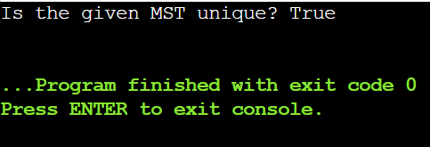

Result:
Is the given MST unique? True.

